Analyzing Earning From Bus Data using Power BI
(2015-2018)

To analyze earnings from bus data using Power BI, we can approach the task in a structured, data-driven manner. Here's a step-by-step guide:
1. Data Preparation
Before visualization, ensure your bus dataset is clean, structured, and ready for data fields may include:
- Bus_ID or Route_Number
- Date of operation / trip
- Number_of_Passengers per trip
- Fare_Collected or Ticket_Revenue
- Distance_Traveled or Route_Length
- Operational_Cost (fuel, maintenance, driver salary)
Key steps:
- Remove duplicates: Ensure unique trip entries.
- Handle missing values: Fill in or discard missing fare or passenger data.
- Normalize data: Ensure consistent units for revenue and distance (e.g., INR, km).
2. Importing Data into Power BI
- Open Power BI Desktop → Get Data → choose source (Excel, CSV, SQL, etc.).
- Load the cleaned dataset into Power BI for analysis.
3. Data Modeling
- Create calculated columns if needed using DAX (Data Analysis Expressions):
  - Total Revenue per Trip: Revenue = Number_of_Passengers * Fare
  - Profit per Trip: Profit = Revenue - Operational_Cost
  - Average Fare per Passenger: Average_Fare = Revenue / Number_of_Passengers
- Define relationships if you have multiple tables (e.g., Bus info, Route info, Revenue info).
4. Creating Visualizations
Focus on visualizations that convey earnings clearly:
- Total Revenue Trends:
  - Line chart showing daily / monthly revenue trends.
- Revenue by Bus / Route:
  - Bar/column chart comparing revenue across different buses or routes.
- Passenger vs. Revenue Analysis:
  - Scatterplot: Number_of_Passengers vs Revenue to observe correlation.
- Profitability Analysis:
  - Map or table showing revenue minus operational costs per route.
- Top Contributors:
  - Pie chart or treemap showing top-performing buses / routes in terms of revenue.
5. Advanced Analytics
- Time Series Analysis: Use DAX to calculate moving averages for revenue trends.
- Forecasting: Power BI’s built-in forecasting feature can predict future earnings.
- Revenue per Kilometer: Revenue_per_km = Revenue / Distance_Traveled to assess efficiency.
- Variance Analysis: Compare actual revenue to planned or expected revenue.
6. Interactive Dashboards
- Incorporate slicers for date ranges, bus routes, and vehicle numbers.
- Ensure drill-throughs and tooltip details for deeper insight into any bus or route performance.
7. Key Metrics / KPIs to Track
- Total Revenue (monthly/annual)
- Average Revenue per Bus / Route
- Occupancy Rate: Number_of_Passengers / Bus Capacity
- Profit Margin: (Revenue - Operational Cost) / Revenue
- Revenue Growth Rate (Month-over-Month)
Source: Dataset link (Dataset source: Open City Urban Data)
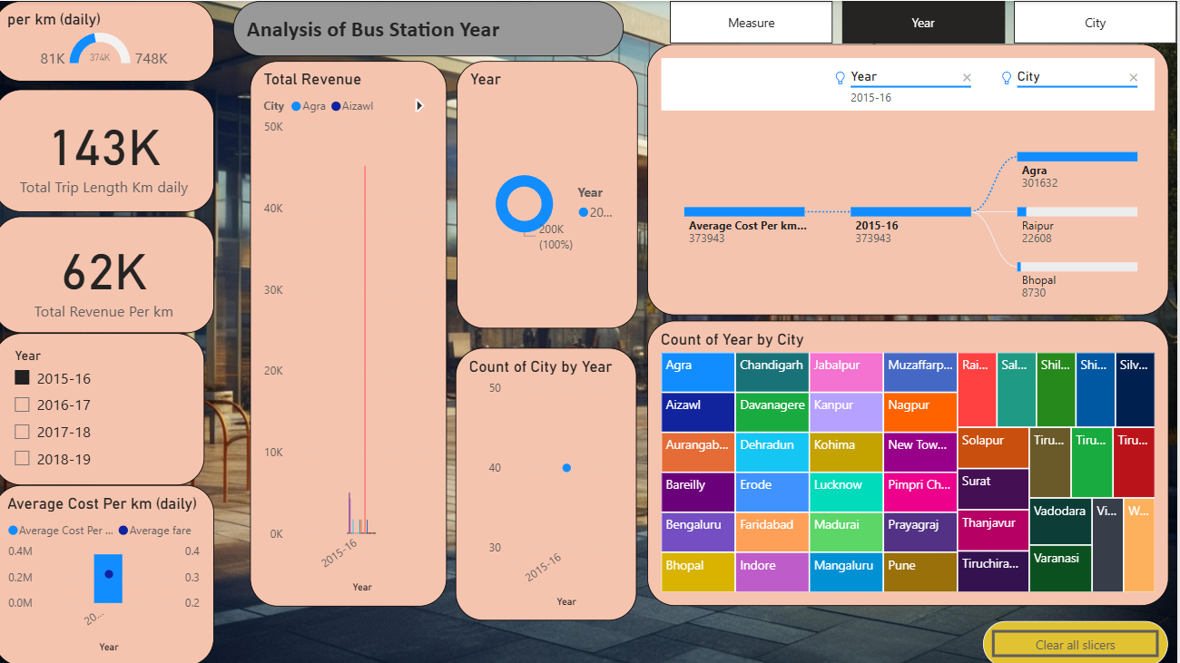
Insights by bus Station for Year
Overall Performance Metrics (KPIs)
The top-level cards provide immediate performance snapshots for the selected filters (Year 2015-16 is likely selected based on other charts):
- Total Revenue: 81K (indicated in one card, while the large central card likely shows 143K Total Trip Length Km daily). The exact currency/unit is not specified.
- Total Trip Length Km daily: 143K km is covered daily.
- Total Revenue Per km: 62K (unit not specified).
- Average Cost Per km (daily): The visuals show average costs per km and average fare around 0.3M to 0.4M and 0.2 respectively for the year 2015-16.
Performance by City and Year
The data appears to be sliced heavily by the year 2015-16.
- City-Specific Data: Several cities are represented, with specific count data visible for a few in the top right "City" card:
  - Agra: 301632 count
  - Raipur: 22608 count
  - Bhopal: 8730 count
- Geographic Distribution: A wide range of cities are included in the dataset, spanning across various regions (e.g., Aizawl, Bengaluru, Kanpur, Madurai, Varanasi, etc.), suggesting a nationwide or large regional analysis.
- Data Distribution Over Time: The bar chart on the left indicates that most of the plotted data points (likely total revenue per km or average cost per km) fall within the 10K to 40K range for the 2015-16 year.
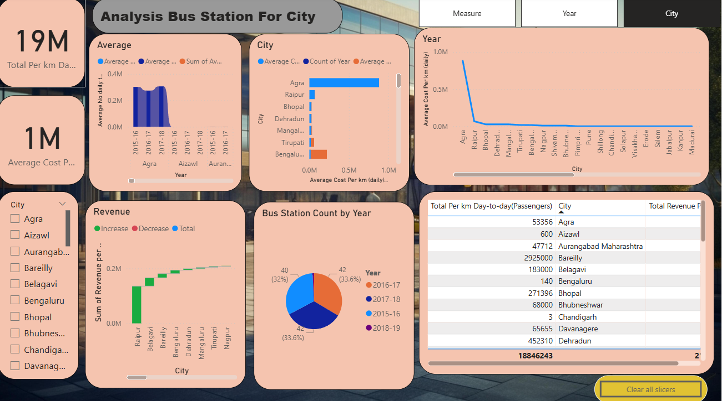
Insights by bus station for year
- Key Performance Indicators (KPIs)
- The main data points highlighted in the large cards are:
- Total Trip Length Km Daily: 19M (19 million kilometers).
- Average Cost Per km: 1M (likely 1 million, but the unit is unclear).
- Total Revenue: 81K (unit unclear; possibly Rupees, Dollars, etc.).
- Total Revenue Per km: 62K (unit unclear).
- Operational Insights & Trends
- Dominant Time Period: The visual data displayed heavily prioritizes the year 2015-16, as indicated by the bar charts and year slicers.
- Cost Efficiency: The line graph in the top right shows a significant drop-off in "Average Cost Per km daily" after the initial few cities (Agra, Raipur, Bhopal, Dehradun, Mangaluru, Tirupati, Bengaluru, Nagpur), suggesting the first few cities might be the most expensive to operate in, or data for others is lower.
- Revenue Trends: The waterfall chart for "Sum of Revenue per..." suggests varying performance across cities. Raipur, Belagavi, and Bareilly show decreases, while Bengaluru and Dehradun show increases.
- Bus Station Count: The donut chart indicates that the number of bus stations is relatively stable across years, with 40 stations (32%) in 2016-17 and 42 stations (33.6%) in 2017-18 and 2018-19.
- Passenger Data & City Performance
- Passenger Count (Daily): The table on the right lists "Total Per km Day-to-day(Passengers)" and "Total Revenue F." (likely revenue for a specific metric).
- Bareilly reports a very high passenger count of 2,925,000.
- Agra reports 53,356 passengers.
- Aurangabad Maharashtra reports 47,712 passengers.
- City Participation: A large number of cities are involved in the analysis, including major hubs like Mumbai, Pune, Chennai, Nagpur, etc., which are visible in the slicers and charts.

Summary
By integrating your bus data into Power BI, you can efficiently track and visualize earns, identify the most profitable routes, and make datadriven operational decisions. Proper cleaning, modeling, and visualization selection, combined with key KPIs, will allow for insights and better strategic planning of bus operations.

